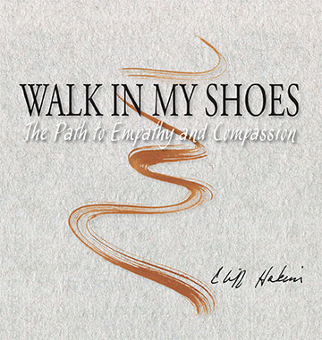
Walk in My Shoes:
The Path to Empathy and Compassion
by Cliff Hakim

Press Release

IN A WORLD DEAF TO THE NEEDS OF OTHERS:

Kindness matters. Compassion is a superpower.

In a world that seems deaf to the needs of others, still empathy and compassion are always in style. Style comes from the inside out. Each of us has special ways of relating to others. In Walk in My Shoes, 35 storytellers show us that kindness matters. Prominent leaders demonstrate that compassion is a superpower. We all possess these capabilities and can use them to contribute to others and to society.

Author Cliff Hakim asked 35 people two questions: What is it like to walk in your own
shoes? What is it like to walk in another’s shoes?

Walk in My Shoes consists of tales of empathy and compassion, with personal interviews and illustrations of each subject’s favorite shoes. The “walk storytellers” all talk about understanding and care. Included are a wide sphere of individuals from educators to activists, psychologists to executives, and artists to healthcare providers. There is also a section on leadership, and a call to action: Your Step––What you say and do matters.

Walk in My Shoes is universally inspiring, showing anyone how to make a difference in
our sea of social problems. The author is asking people of all ages and genders to join him in one simple step of kindness per day to contribute to creating a healthier, happier society. Learn to Walk the Walk in this new era.

In comparison to other books on empathy such as The Empathy Exams by Leslie Jamison, The Empathy Effect by Dr. Helen Riess, and The Empath’s Survival Guide by Dr. Judith Orloff, Walk in My Shoes is not academic, but a fluid and visual expression of the heart and soul. Walk offers learning by example. It encourages one to focus on the shoes of others and their stories. It asks us to heed a compassionate and inspiring call to action: take one step of kindness and then another. Cliff Hakim’s book literally and figuratively draws the reader in to imagine their own shoes and their own steps and where they have taken them throughout life. The author and walk storytellers show the reader that he or she can become more aware and able. They too can make a difference by stepping into another’s shoes.

